Chapter 1
- A Copper bar with a diameter of 1.2cm and length 20cm is insulated with micanite which fits tightly around the bar and into the rotor slot of induction motor. Thickness of the micanite tube is 1.5mm and thermal resistivity is $8Ω$. Calculate the loss that will pass from copper bar to iron for a temperature difference of ${25}^{∘}$ C maintained between them.
Solution:
Diameter of Copper Bar, D = 12mm = 12*${10}^{-3}$m
Thickness of Micanite Tube, t = 1.5mm = 1.5*${10}^{-3}$m
Thermal Resistivity ($ρ$) = $8Ω$
Temperature difference, ($θ_{1}-θ_{2}$) = ${25}^{∘}$ C
Length of Copper bar, L = 0.2m
Loss that will pass from copper bar to iron, $Q_{con}$ = ($θ_{1}-θ_{2}$)/$R_{θ}$
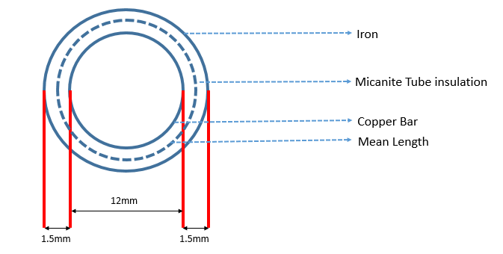
Thermal Resistance, $R_{θ}$ = $\frac{ρ*t}{s}$
Surface area of insulation s = π*(D + t)*L = π*(12+1.5)*${10}^{-3}$*0.2 = 8.4823*${10}^{-3}m^{2}$
$R_{θ}$ = $\frac{8*1.5*{10}^{-3}}{8.4823*{10}^{-3}}$ = 11.4147 $Ω$
$Q_{con}$ = $\frac{25}{1.4147}$ = 17.6715 W

